EXCRETION REVISION WACE 2014

# Question 40 (20 marks)

1. The nephron is the primary structure concerned with the formation of urine. It is composed of a number of parts, including the:
   1. glomerulus
   2. proximal convoluted tubule
   3. distal convoluted tubule
   4. collecting duct.

Describe the role played by each of these nephron parts in the formation of urine.

(13 marks)

1. To perform their function, regions along the nephron must move substances across a membrane. Processes that enable this to occur include:
   1. diffusion
   2. osmosis
   3. active transport.

Describe each of these processes. (7 marks)

Q 33 WACE 203

Parts (a), (b) and (c) of the question refer to the diagram of the nephron shown below.

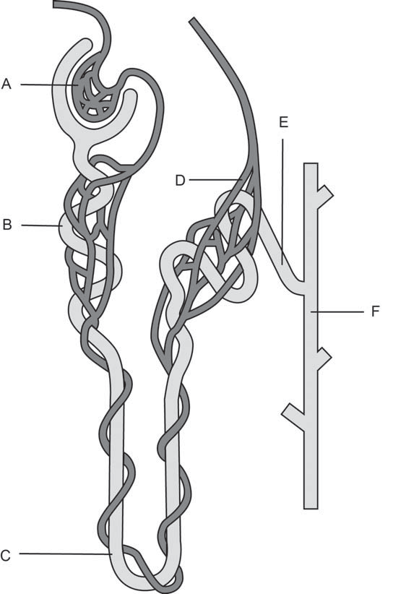

1. Identify the structures labelled ‘B’ and ‘C.’ (2 marks) B: C:
2. State the function of the structures labelled ‘A’ and ‘D’. (2 marks) A: D:
3. What function do the structures labelled ‘E’ and ‘F’ perform that affects the composition of urine? (4 marks)

E:

F:

1. Name the organ of the body that produces urea. (1 mark)